**Project II:**

* Create outline of idea for Project 2
  + Use d3, one JS (but leverage a lot of JS functionality)
  + Define dataset and domain for project 2

10-minute presentation:

* Domain:
* Dataset:
* Theme:
* Coding approach:
* Data munging techniques:
* Final visualization:

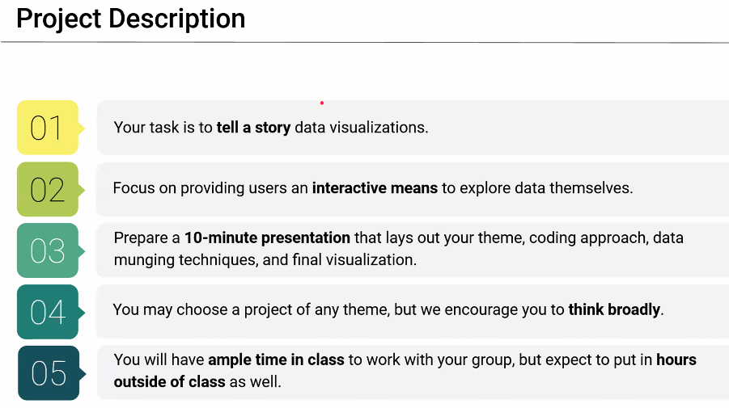

* Deploy on github and Heroku
* Finite instructions; boundaries involved to cover several skill sets
* Think broadly; go for a new domain that I haven’t covered before
  + i.e., Finance, Manufacturing, etc… Places I haven’t walked before
  + dataset should be domain specific
* Decide on domain first, then look for data
* Requirements:

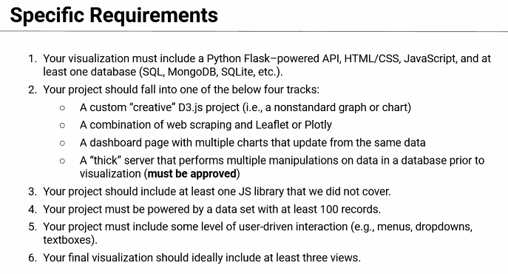

* Use kaggle for domains / datasets
* #3… see react, angulars
* #6… at least three charts for one dashboard
* Start determining topic (domain), then find dataset, then sketch visual ideas
* Ideas:
  + insurance claims by type (auto, home, life) by age, income… AAA

